Project Design Phase-II
Data Flow Diagram & User Stories

Date | 8 June 2026
Team ID | LTVIP2026TMIDS79672
Project Name | ToyCraft Tales: Tableau's vision into toy manufacturer data
Maximum Marks | 4 Marks

Data Flow Diagrams:
A Data Flow Diagram (DFD) is a traditional visual representation of the information flows within a system. A neat and clear DFD can depict the right amount of the system requirement graphically. It shows how data enters and leaves the system, what changes the information, and where data is stored.

Example: (Simplified)

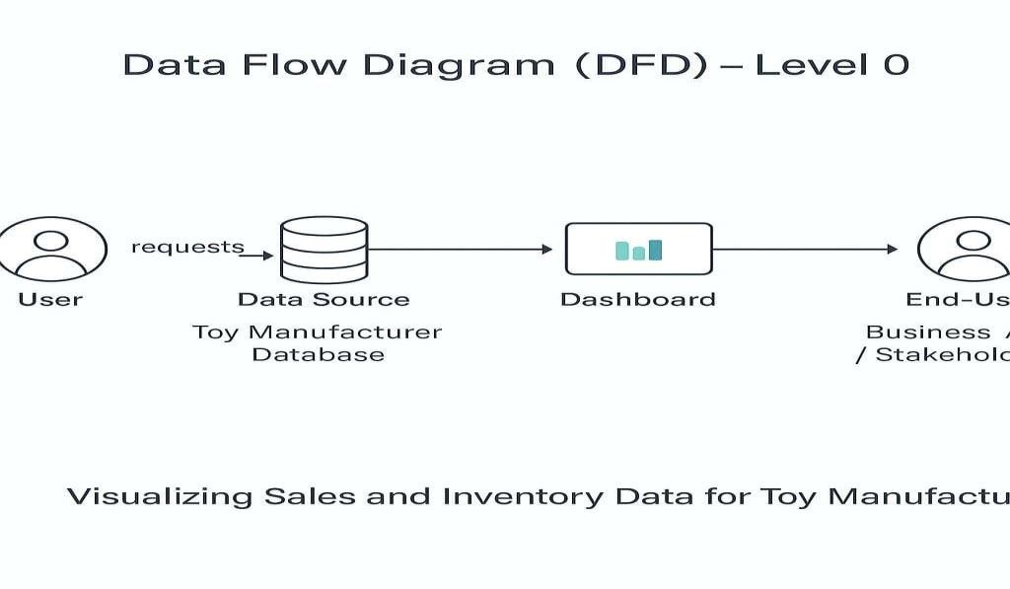
User Stories

User Type | Functional  Requirement (Epic) | User Story  Number | User Story / Task | Acceptance  Criteria | Priority / Release
Data Analyst | Data Upload | USN-1 | As a Data Analyst, I can upload Sales and Inventory data to the system | Data successfully uploaded & validated | High / Sprint-1
Data Analyst | Dashboard View | USN-2 | As a Data Analyst, I can view the Sales & Inventory dashboards in Tableau | Visualizations render correctly in Tableau | High / Sprint-1
Business Manager (End-User) | Report Generation | USN-3 | As a Business Manager, I can generate monthly  Sales reports | Report generated accurately & downloadable | Medium / Sprint-2
Business Manager (End-User) | Inventory Alerts | USN-4 | As a Business Manager, I receive low-inventory alerts | Alert triggers when stock levels fall below threshold | High / Sprint-1

